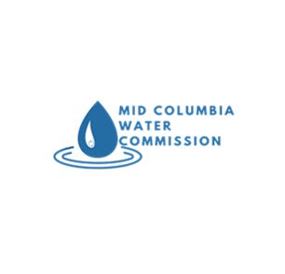Sent Via Electronic Mail

**MEMO**

To: Greg Silbernagel, OWRD Watermaster

Chris Kowitz, OWRD Region 5 Manager

From: J.R. Cook & Gibb Evans, Commission Contract Staff

CC: Jake Madison, Commission Chair

Mid-Columbia Water Commission

NOWA Board of Directors

Attachments: No Attachments

RE: Permit #S-55192 (2020 Annual Report and 2021 Confirmation of Loss of Mitigation Water)

**Introduction**

Pursuant to Condition 16 of Permit #S-55192, the water rights holder is required to provide an annual water use report by February 14 of each year, including a forecast for the expected use of Permit #S-55192 for the upcoming irrigation season. In November, 2020 the Mid-Columbia Water Commission was legally formed and has assumed administrative responsibilities for all Mid-Columbia Mitigation Use Rights currently in use. The following report includes information to comply with reporting Sub-Conditions a, b, c and d of Condition 16.

**2020 Irrigation Season Water Use**

Prior to the beginning of the irrigation season the water rights owner was informed that an instream lease application (IL-1784) was not going to be approved. To ensure compliance with mitigation rate conditions, the water right holder decided not to activate and use any of #S-55192. Therefore, no water use in 2020 occurred under this water right.

**Condition 16 (b)**

The following summary is required by and consistent with Condition 16(b) of Permit S-55192:

1. Planned activity for 2021 irrigation season: Due to a lack of adequate mitigation sources for 2021 the Commission has elected not to activate #S-55192 for the 2021 irrigation season.
2. The Commission wishes to note that this is the second year that this permit has not been activated due to a lack of adequate mitigation sources.
3. The Commission intends to activate this water right for the 2022 irrigation season to maintain compliance and validity of this water right.

**Condition 16(c**)

Mitigation water rights users formed the Mid-Columbia Water Commission (Commission) in 2020 to administer both temporary mitigation and begin working on programmatic mitigation necessary to certificate mitigation use rights in the future. The Commission has begun discussions with the State of Washington and congressional representatives on the possibility of a one-time permanent acquisition of enough “non-treaty” storage water owned in Canada by BC Hydro to permanently mitigate all water rights associated with the Mid-Columbia mitigation effort. These discussions are preliminary and will require Sovereign negotiation between the State of Washington, State of Oregon and affected tribal governments. The Commission has placed a volumetric target on programmatic mitigation of 170,000 acre-feet which is enough water to mitigate the 500 cfs of targeted mitigation demand in the Mid-Columbia region of Oregon.